**Stduio 7**

**Exercise1:** Qitao Xu, Jiangnan Liu, Zhe Wang

**Exercise2**:

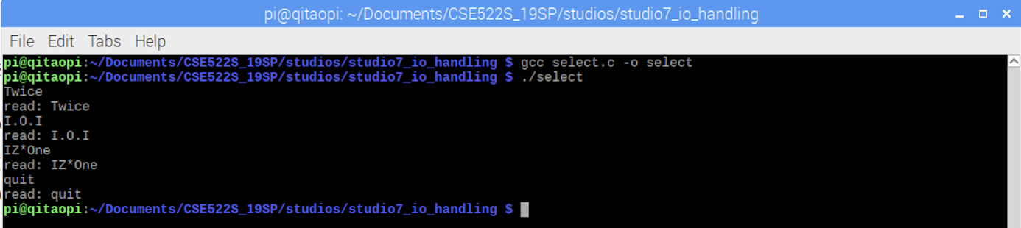

**Exercise3**:

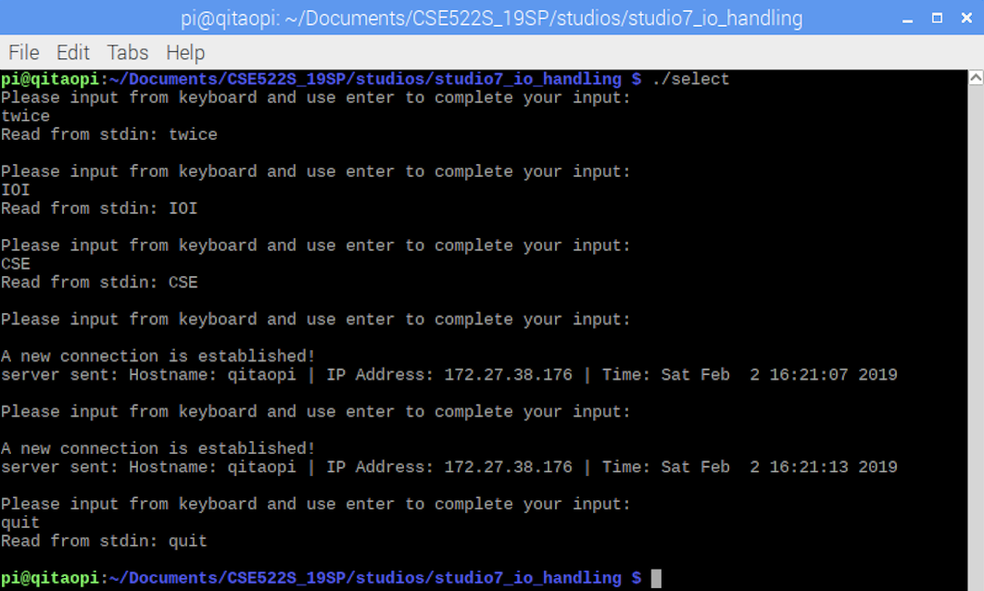

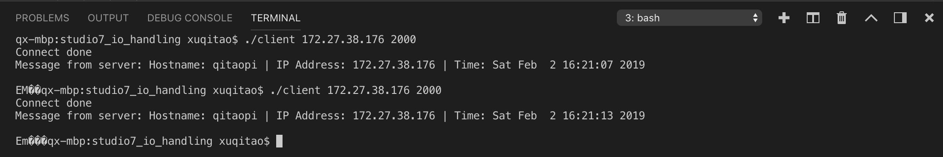

**Exercise4**:

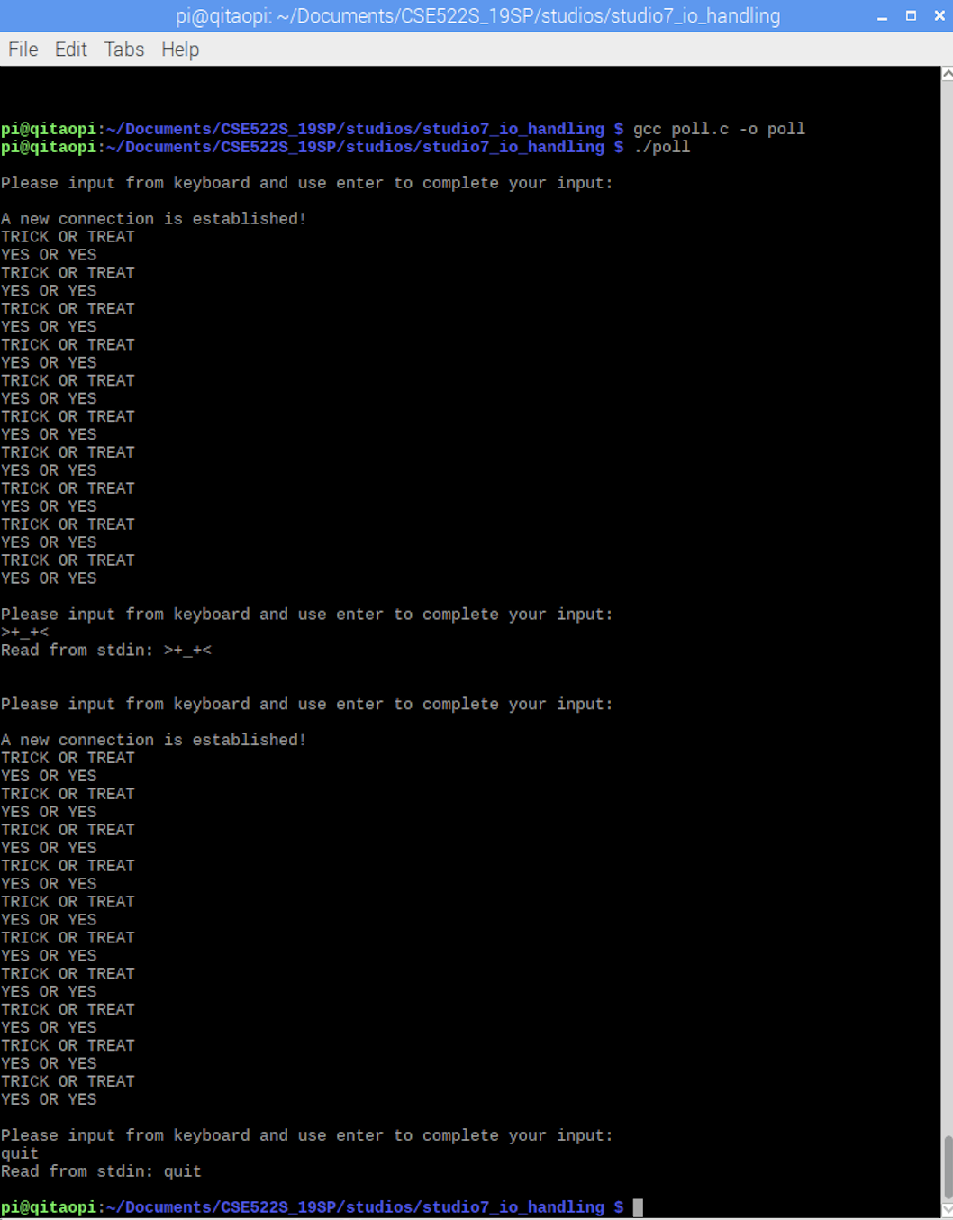



**Exercise5**:

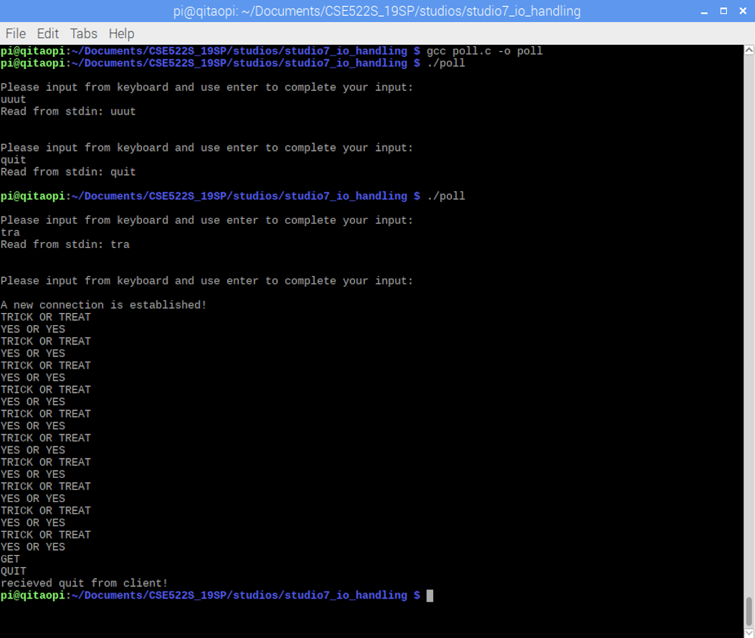



**Exercise6**:

Edge-triggered:



Level-triggered:

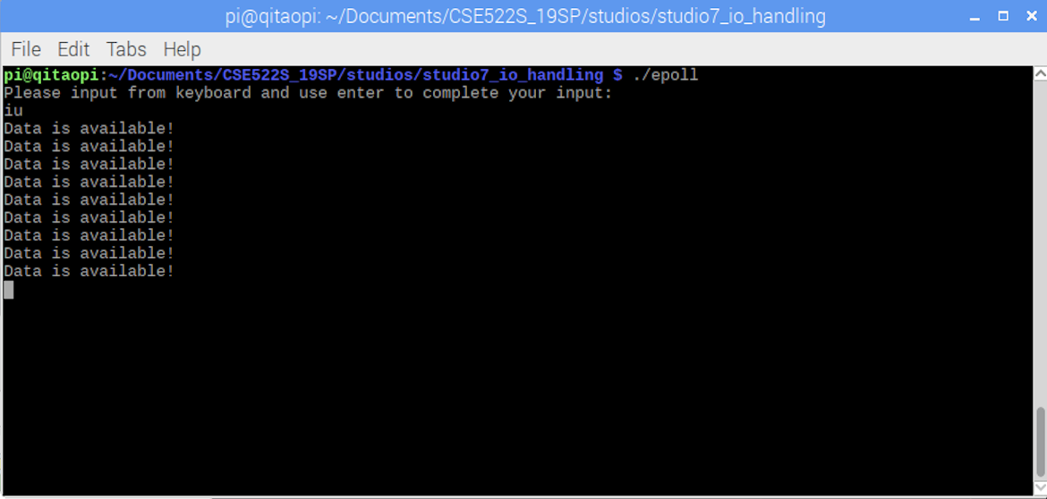

With a level-triggered watch, the call to epoll_wait() will return immediately, showing that the pipe is ready to read. With an edge-triggered watch, this call will not return until data are written to the pipe.